**DATABASE SCHEMA**

-- MySQL Script generated by MySQL Workbench

-- Tue Mar 21 01:53:40 2023

-- Model: New Model Version: 1.0

-- MySQL Workbench Forward Engineering

SET @OLD_UNIQUE_CHECKS=@@UNIQUE_CHECKS, UNIQUE_CHECKS=0;

SET @OLD_FOREIGN_KEY_CHECKS=@@FOREIGN_KEY_CHECKS, FOREIGN_KEY_CHECKS=0;

SET @OLD_SQL_MODE=@@SQL_MODE, SQL_MODE='ONLY_FULL_GROUP_BY,STRICT_TRANS_TABLES,NO_ZERO_IN_DATE,NO_ZERO_DATE,ERROR_FOR_DIVISION_BY_ZERO,NO_ENGINE_SUBSTITUTION';

-- -----------------------------------------------------

-- Schema mydb

-- -----------------------------------------------------

-- -----------------------------------------------------

-- Schema webscrapper

-- -----------------------------------------------------

-- -----------------------------------------------------

-- Schema webscrapper

-- -----------------------------------------------------

CREATE SCHEMA IF NOT EXISTS `webscrapper` DEFAULT CHARACTER SET utf8mb4 COLLATE utf8mb4_0900_ai_ci ;

USE `webscrapper` ;

-- -----------------------------------------------------

-- Table `webscrapper`.`car`

-- -----------------------------------------------------

CREATE TABLE IF NOT EXISTS `webscrapper`.`car` (

`id` BIGINT NOT NULL AUTO_INCREMENT,

`make` VARCHAR(255) NOT NULL,

`model` VARCHAR(255) NOT NULL,

`price` DOUBLE NOT NULL,

`year` INT NOT NULL,

PRIMARY KEY (`id`))

ENGINE = InnoDB

DEFAULT CHARACTER SET = utf8mb4

COLLATE = utf8mb4_0900_ai_ci;

-- -----------------------------------------------------

-- Table `webscrapper`.`user`

-- -----------------------------------------------------

CREATE TABLE IF NOT EXISTS `webscrapper`.`user` (

`id` BIGINT NOT NULL AUTO_INCREMENT,

`email` VARCHAR(255) NOT NULL,

`password` VARCHAR(255) NOT NULL,

`username` VARCHAR(255) NOT NULL,

`last_name` VARCHAR(255) NULL DEFAULT NULL,

`first_name` VARCHAR(255) NULL DEFAULT NULL,

PRIMARY KEY (`id`))

ENGINE = InnoDB

DEFAULT CHARACTER SET = utf8mb4

COLLATE = utf8mb4_0900_ai_ci;

-- -----------------------------------------------------

-- Table `webscrapper`.`search_criteria`

-- -----------------------------------------------------

CREATE TABLE IF NOT EXISTS `webscrapper`.`search_criteria` (

`id` BIGINT NOT NULL AUTO_INCREMENT,

`make` VARCHAR(255) NOT NULL,

`max_price` DOUBLE NOT NULL,

`max_year` INT NOT NULL,

`min_price` DOUBLE NOT NULL,

`min_year` INT NOT NULL,

`model` VARCHAR(255) NOT NULL,

`user_id` BIGINT NOT NULL,

PRIMARY KEY (`id`),

INDEX `FKfjbxph0g1jr8wf2hh1p4baanf` (`user_id` ASC) VISIBLE,

CONSTRAINT `FKfjbxph0g1jr8wf2hh1p4baanf`

FOREIGN KEY (`user_id`)

REFERENCES `webscrapper`.`user` (`id`))

ENGINE = InnoDB

DEFAULT CHARACTER SET = utf8mb4

COLLATE = utf8mb4_0900_ai_ci;

-- -----------------------------------------------------

-- Table `webscrapper`.`website`

-- -----------------------------------------------------

CREATE TABLE IF NOT EXISTS `webscrapper`.`website` (

`id` BIGINT NOT NULL AUTO_INCREMENT,

`html_tags` VARCHAR(255) NULL DEFAULT NULL,

`url` VARCHAR(255) NULL DEFAULT NULL,

PRIMARY KEY (`id`))

ENGINE = InnoDB

DEFAULT CHARACTER SET = utf8mb4

COLLATE = utf8mb4_0900_ai_ci;

-- -----------------------------------------------------

-- Table `webscrapper`.`search_result`

-- -----------------------------------------------------

CREATE TABLE IF NOT EXISTS `webscrapper`.`search_result` (

`id` BIGINT NOT NULL AUTO_INCREMENT,

`car_id` BIGINT NOT NULL,

`user_id` BIGINT NOT NULL,

`website_id` BIGINT NULL DEFAULT NULL,

PRIMARY KEY (`id`),

INDEX `FK6ivl8vmv3f0ewuaoq222msbf3` (`car_id` ASC) VISIBLE,

INDEX `FK9n6ea934u0ieetkr6o5u31jyr` (`user_id` ASC) VISIBLE,

INDEX `FKovovn6cluvp418nllm2uwduik` (`website_id` ASC) VISIBLE,

CONSTRAINT `FK6ivl8vmv3f0ewuaoq222msbf3`

FOREIGN KEY (`car_id`)

REFERENCES `webscrapper`.`car` (`id`),

CONSTRAINT `FK9n6ea934u0ieetkr6o5u31jyr`

FOREIGN KEY (`user_id`)

REFERENCES `webscrapper`.`user` (`id`),

CONSTRAINT `FKovovn6cluvp418nllm2uwduik`

FOREIGN KEY (`website_id`)

REFERENCES `webscrapper`.`website` (`id`))

ENGINE = InnoDB

DEFAULT CHARACTER SET = utf8mb4

COLLATE = utf8mb4_0900_ai_ci;

SET SQL_MODE=@OLD_SQL_MODE;

SET FOREIGN_KEY_CHECKS=@OLD_FOREIGN_KEY_CHECKS;

SET UNIQUE_CHECKS=@OLD_UNIQUE_CHECKS;

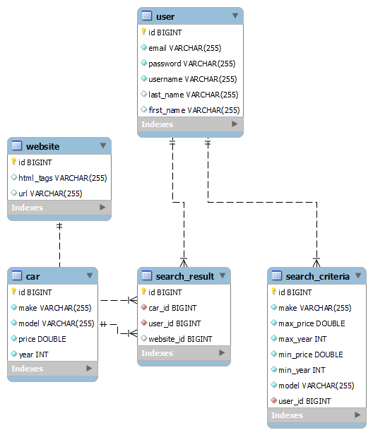

Entity Relationship Diagram